Zomato Data Analysis:
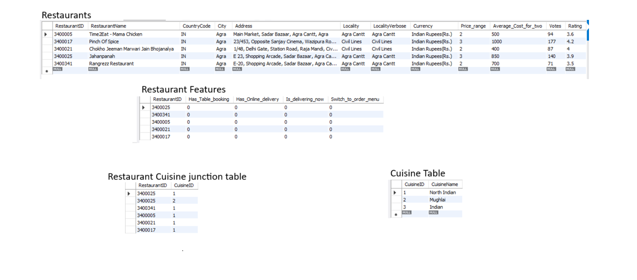

- One-to-Many: One row relates to multiple rows in another table
- Many-to-Many: Multiple rows relate to multiple rows using a junction table
- One-to-One: Each row maps to exactly one row
- Many-to-One: Reverse of one-to-many

Relationship | Meaning | Example | Special Rule
1:1 | One ↔ One | Person ↔ Passport | Rare
1:N | One → Many | Customer → Orders | FK in "many" table
N:1 | Many → One | Students → College | Same as 1:N
M:N | Many ↔ Many | Restaurants ↔ Cuisines | Use junction table

